Literacy
Using some quality texts, children will develop their sentence writing alongside exploring the past through the medium of literacy. We will read favourite, ‘Dogger’ by Alfie Hughes, before going on to use ‘Lost in the Toy Museum’, ‘Old Bear’ and ‘That Rabbit Belongs to Emily Brown’. Children will use the style of the prose in the last book to create their own retell. We will be working on applying our phonic knowledge to write phonetically plausible sentences, introducing capital letters and full stops!
Expressive Arts and Design – Art
This term’s focus will be on a famous artist. We will look at the work of Alexander Calder. With a final focus on DT and toys, children will look at his expressionist work, create their own version of one of his paintings, and have a go at making a sculpture or two inspired by his own.
Maths
Children will continue to practise and refine their core skills of subitising, including conceptual subitising; knowing that numbers over 5 are what they are because they see 5 ‘and some more’, counting, and comparison and composition. When the children can compose and flexibly decompose numbers mentally, they will become more fluent in their knowledge of number bonds and will be able to use these to become efficient when calculating in Key Stage 1 and Key Stage 2.

Fe
Understanding the World – people, culture and communities
Through the topic, children will continue to develop their understanding of history. Using real life toys, they will consider which toys belong to the past and which the present. They will justify ‘why’ according to the function of the toy and the materials used, and consider what it would be like to be a child from the past.
PE
This term, children will learn how to control the speed and direction of a ball as they learn to play basketball.

RE
Our ‘Big Question’ this term will be; Does everyone believe in God?’ We will address this question in the context of Easter.

PSHE
This term’s SCARF unit is all about finding out about our rights, and how we can respect those of others.

Expressive Arts and Design – Music
Children will continue to develop their sense of rhythm using Charanga, and the musician of the month. We will use instruments to develop their skills and enjoyment.
Spring 2, Robins Class
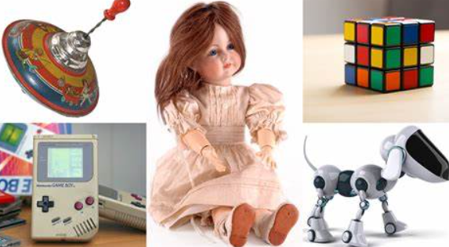
Toys; Past and Present

Understanding the world – the natural world
As spring continues to emerge, the children will use their knowledge of the seasons to observe changes. We will use nature walks to look at similarities and differences between plants and trees, and look for minibeasts as we explore the natural world around our school.

