P.E.
P.E will be as usual on Thursdays and Fridays. The children will be learning and playing tag rugby.
Maths
This term we will first be continuing with work on Addition and Subtraction, using mathematical resources to support our written methods. Then we will move onto Multiplication and Division, thinking carefully about the relationships and patterns.
English
In English this term we will be using ideas from the book ‘Tin Forest’ to explore a range of writing techniques. We will discuss what the effect the author is trying to create, how they are doing it, and how we can do the same thing. Our ‘Writing to Entertain’ work will be a setting description from the perspective of an animal in the forest.

Computing
This term we will begin to use the programming platform ‘Scratch’ to learn the basics of coding and sequencing.

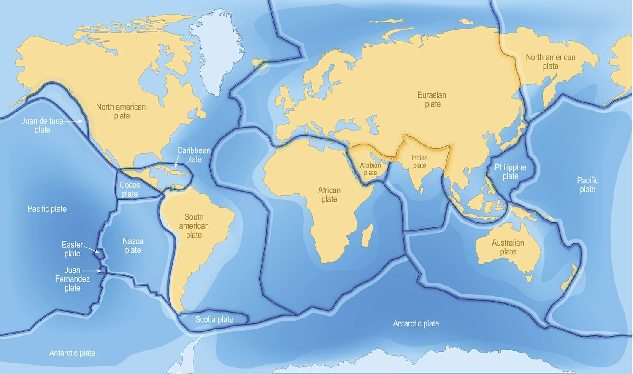

Extreme Earth

Bluebirds
Autumn Term 2 2025

RE
Our question in RE this term is ‘How does the worldwide Christian family celebrate, worship and mark key events?’. We will focus on Christmas and Easter celebrations around the world.
Science
Electricity - We will be using scientific language to describe electric circuits, identifying and naming basic parts, as well as learning how to identify open and closed circuits.

PSHE
This term we will be focusing on the topic of ‘Valuing Difference’, exploring what makes us diverse and how important this is.
French
We will develop our knowledge of French greetings, as well as introducing the French names for days of the week.
Music
We will be practising playing music using the recorder this term, as well as learning and rehearsing some songs for our Young Voices trip.

DT
Kites – This term, our project is to make our own kites. To do this we will first learn about how kites work, before designing and creating our own.
Geography
Extreme Earth: This term, our topic is all about planet Earth, and the extreme things which can happen. We will begin by learning about what is beneath our feet, the tectonic plates, which leads us to volcanoes, earthquakes, and tsunamis, looking at what causes them and what the effects are. We will also discuss other natural events such as tornadoes.

